1. Write a program to check if a number is positive, negative, or zero.

#include <stdio.h>

int main() {

int number;

// Ask user to enter a number

printf("Enter a number: ");

scanf("%d", &number);

// Check if number is positive, negative or zero

if (number > 0) {

printf("The number is positive.\n");

} else if (number < 0) {

printf("The number is negative.\n");

} else {

printf("The number is zero.\n");

}

return 0;

}

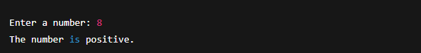

1. Write a program to find the largest among three numbers.

#include <stdio.h>

int main() {

int num1, num2, num3;

// Input three numbers

printf("Enter three numbers: ");

scanf("%d %d %d", &num1, &num2, &num3);

// Find the largest

if (num1 >= num2 && num1 >= num3) {

printf("The largest number is: %d\n", num1);

} else if (num2 >= num1 && num2 >= num3) {

printf("The largest number is: %d\n", num2);

} else {

printf("The largest number is: %d\n", num3);

}

return 0;

}

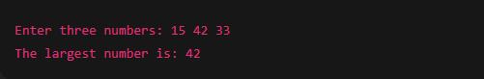

1. Write a program to check if a year is a leap year.

#include <stdio.h>

int main() {

int year;

// Ask user to input the year

printf("Enter a year: ");

scanf("%d", &year);

// Leap year check

if ((year % 4 == 0 && year % 100 != 0) || (year % 400 == 0)) {

printf("%d is a leap year.\n", year);

} else {

printf("%d is not a leap year.\n", year);

}

return 0;

}

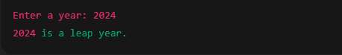

1. Write a program to check whether a character is a vowel or consonant.

#include <stdio.h>

int main() {

char ch;

// Ask user to enter a character

printf("Enter an alphabet: ");

scanf(" %c", &ch); // Note the space before %c to catch newline

// Check if the input is an alphabet

if ((ch >= 'A' && ch <= 'Z') || (ch >= 'a' && ch <= 'z')) {

// Check for vowels

if (ch == 'A' || ch == 'E' || ch == 'I' || ch == 'O' || ch == 'U' ||

ch == 'a' || ch == 'e' || ch == 'i' || ch == 'o' || ch == 'u') {

printf("%c is a vowel.\n", ch);

} else {

printf("%c is a consonant.\n", ch);

}

} else {

printf("Invalid input. Please enter an alphabet.\n");

}

return 0;

}

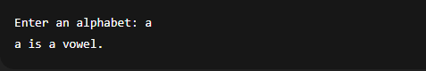

1. Write a program to assign grades based on marks.

#include <stdio.h>

int main() {

int marks;

// Get marks from user

printf("Enter your marks (0 - 100): ");

scanf("%d", &marks);

// Check for valid range

if (marks < 0 || marks > 100) {

printf("Invalid marks! Please enter a value between 0 and 100.\n");

} else {

// Assign grades

if (marks >= 90) {

printf("Grade: A\n");

} else if (marks >= 80) {

printf("Grade: B\n");

} else if (marks >= 70) {

printf("Grade: C\n");

} else if (marks >= 60) {

printf("Grade: D\n");

} else if (marks >= 50) {

printf("Grade: E\n");

} else {

printf("Grade: F (Fail)\n");

}

}

return 0;

}

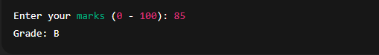

1. Write a program to check whether a number is divisible by 5 and 11.

#include <stdio.h>

int main() {

int number;

// Input from user

printf("Enter a number: ");

scanf("%d", &number);

// Check if number is divisible by both 5 and 11

if (number % 5 == 0 && number % 11 == 0) {

printf("%d is divisible by both 5 and 11.\n", number);

} else {

printf("%d is NOT divisible by both 5 and 11.\n", number);

}

return 0;

}

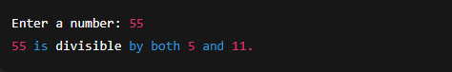

1. Write a program to find the absolute value of a number.

#include <stdio.h>

int main() {

int number, absolute;

// Input from user

printf("Enter an integer: ");

scanf("%d", &number);

// Calculate absolute value

if (number < 0) {

absolute = -number;

} else {

absolute = number;

}

// Display result

printf("The absolute value is: %d\n", absolute);

return 0;

}

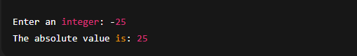

1. Write a menu-driven program to perform +, -, \*, / operations.

#include <stdio.h>

int main() {

int choice;

float num1, num2, result;

// Display menu

printf("Simple Calculator Menu:\n");

printf("1. Addition (+)\n");

printf("2. Subtraction (-)\n");

printf("3. Multiplication (\*)\n");

printf("4. Division (/)\n");

printf("Enter your choice (1-4): ");

scanf("%d", &choice);

// Input two numbers

printf("Enter two numbers: ");

scanf("%f %f", &num1, &num2);

// Perform operation based on user choice

switch (choice) {

case 1:

result = num1 + num2;

printf("Result: %.2f + %.2f = %.2f\n", num1, num2, result);

break;

case 2:

result = num1 - num2;

printf("Result: %.2f - %.2f = %.2f\n", num1, num2, result);

break;

case 3:

result = num1 \* num2;

printf("Result: %.2f \* %.2f = %.2f\n", num1, num2, result);

break;

case 4:

if (num2 == 0) {

printf("Error: Division by zero is not allowed.\n");

} else {

result = num1 / num2;

printf("Result: %.2f / %.2f = %.2f\n", num1, num2, result);

}

break;

default:

printf("Invalid choice. Please enter a number between 1 and 4.\n");

}

return 0;

}

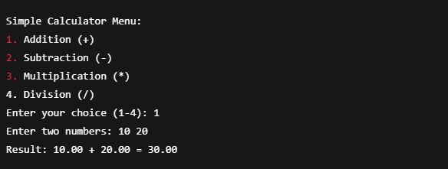

1. Write a program to find roots of a quadratic equation.

#include <stdio.h>

int main() {

float a, b, c, d, r1, r2, real, imag;

printf("Enter a, b, c: ");

scanf("%f %f %f", &a, &b, &c);

d = b\*b - 4\*a\*c;

if(d > 0) {

r1 = (-b + sqrt(d)) / (2\*a);

r2 = (-b - sqrt(d)) / (2\*a);

printf("Roots: %.2f and %.2f\n", r1, r2);

} else if(d == 0) {

r1 = -b / (2\*a);

printf("Root: %.2f\n", r1);

} else {

real = -b / (2\*a);

imag = sqrt(-d) / (2\*a);

printf("Roots: %.2f + %.2fi and %.2f - %.2fi\n", real, imag, real, imag);

}

return 0;

}

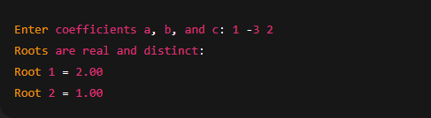

1. Write a program to find the number of digits in a number.

#include <stdio.h>

int main() {

int number, count = 0;

printf("Enter a number: ");

scanf("%d", &number);

// Handle zero explicitly

if (number == 0) {

count = 1;

} else {

if (number < 0) {

number = -number; // Make number positive

}

while (number != 0) {

number /= 10;

count++;

}

}

printf("Number of digits: %d\n", count);

return 0;

}

